BOOK REVIEW
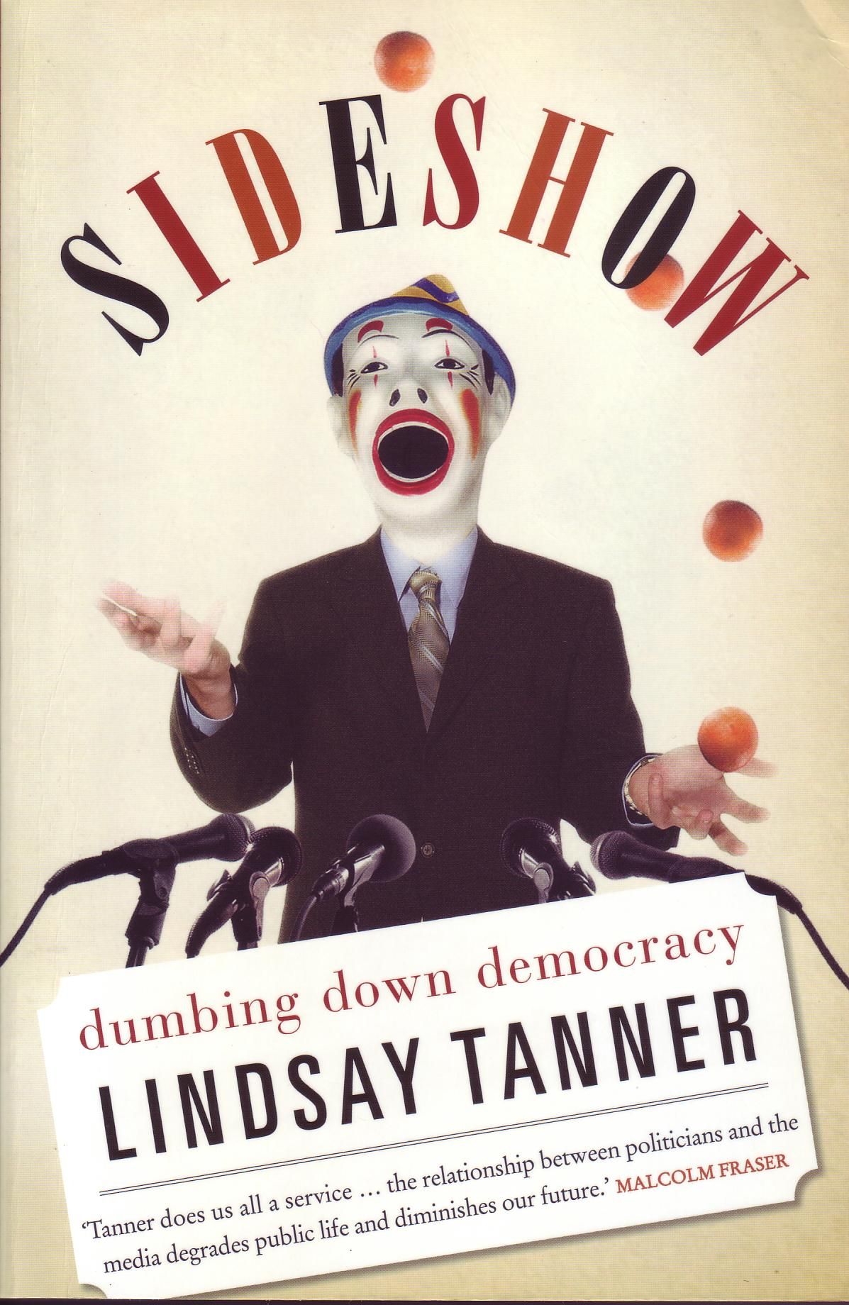
BOOK REVIEW – Phillip Moore
SIDE SHOW: DUMBING DOWN DEMOCRACY
By LINDSAY TANNER. Scribe $32.95

This thoughtful and provocative publication by Lindsay Tanner, a person who has dedicated much of his life to the craft of politics, analyses the interplay that exists between politics and the media.

He describes how the media are retreating into an entertainment frame that has little tolerance for complex and social issues and how politicians and parties in turn are adapting their behaviour to suit the new rules of the game – to such an extent that the contest of ideas is being supplanted by the contest for (entertainment) laughs.

While its outward forms remain in place, the quality of our democracy is being undermined from within. One of its critical components, a free and fearless media is turning into a carnival show.

Readers are reminded of a previous article on democracy in our last newsletter when we outlined the many challenges to our Australian democracy which even with its various weaknesses, is still considered one of the best and most stable in the world. We must be ever vigilant and the challenge that Lindsay Tanner throws down to us all is to stop the whole process of interplay between the media and politics becoming a Sideshow – A Dumbing Down of Democracy.
BOOK REVIEW – Phillip Moore
SIDE SHOW: DUMBING DOWN DEMOCRACY
By LINDSAY TANNER. Scribe $32.95

This thoughtful and provocative publication by Lindsay Tanner, a person who has dedicated much of his life to the craft of politics, analyses the interplay that exists between politics and the media.

He describes how the media are retreating into an entertainment frame that has little tolerance for complex and social issues and how politicians and parties in turn are adapting their behaviour to suit the new rules of the game – to such an extent that the contest of ideas is being supplanted by the contest for (entertainment) laughs.

While its outward forms remain in place, the quality of our democracy is being undermined from within. One of its critical components, a free and fearless media is turning into a carnival show.

Readers are reminded of a previous article on democracy in our last newsletter when we outlined the many challenges to our Australian democracy which even with its various weaknesses, is still considered one of the best and most stable in the world. We must be ever vigilant and the challenge that Lindsay Tanner throws down to us all is to stop the whole process of interplay between the media and politics becoming a Sideshow – A Dumbing Down of Democracy.

BOOK REVIEW – Phillip Moore
SIDE SHOW: DUMBING DOWN DEMOCRACY
By LINDSAY TANNER. Scribe $32.95

This thoughtful and provocative publication by Lindsay Tanner, a person who has dedicated much of his life to the craft of politics, analyses the interplay that exists between politics and the media.

He describes how the media are retreating into an entertainment frame that has little tolerance for complex and social issues and how politicians and parties in turn are adapting their behaviour to suit the new rules of the game – to such an extent that the contest of ideas is being supplanted by the contest for (entertainment) laughs.

While its outward forms remain in place, the quality of our democracy is being undermined from within. One of its critical components, a free and fearless media is turning into a carnival show.

Readers are reminded of a previous article on democracy in our last newsletter when we outlined the many challenges to our Australian democracy which even with its various weaknesses, is still considered one of the best and most stable in the world. We must be ever vigilant and the challenge that Lindsay Tanner throws down to us all is to stop the whole process of interplay between the media and politics becoming a Sideshow – A Dumbing Down of Democracy.

BOOK REVIEW – Phillip Moore
SIDE SHOW: DUMBING DOWN DEMOCRACY
By LINDSAY TANNER. Scribe $32.95

This thoughtful and provocative publication by Lindsay Tanner, a person who has dedicated much of his life to the craft of politics, analyses the interplay that exists between politics and the media.

He describes how the media are retreating into an entertainment frame that has little tolerance for complex and social issues and how politicians and parties in turn are adapting their behaviour to suit the new rules of the game – to such an extent that the contest of ideas is being supplanted by the contest for (entertainment) laughs.

While its outward forms remain in place, the quality of our democracy is being undermined from within. One of its critical components, a free and fearless media is turning into a carnival show.

Readers are reminded of a previous article on democracy in our last newsletter when we outlined the many challenges to our Australian democracy which even with its various weaknesses, is still considered one of the best and most stable in the world. We must be ever vigilant and the challenge that Lindsay Tanner throws down to us all is to stop the whole process of interplay between the media and politics becoming a Sideshow – A Dumbing Down of Democracy.

